Charitable Giving at St George’s Hanover Square

“I was hungry and you gave me food, I was thirsty and you gave me drink, I was a stranger and you welcomed me.”
(Matthew 25: 31-40)

These words of Jesus, as he addressed his followers, have as much relevance today as they did more than 2000 years ago.

In our school, we discuss ways to challenge poverty, injustice and inequality. These discussions raise our awareness to the plight of other members of God’s family, both close to home and in far off lands. We support our brothers and sisters through the school’s programme of charitable giving. The school council, made up exclusively of pupils, manages many of our initiatives. The whole school community is encouraged to engage in social action and to be courageous advocates for change in the local area, national and global communities.

Pupils donate to those in our local community who are most in need through the foodbank. We have a basket in our school lobby where donations of foods and toiletries can be given at any time. Just pop in to the school office to donate.

From the proceeds of our annual Movie Night, we donate to The Children’s Society.

The Children’s Society supports vulnerable children in the UK facing a wide range of challenges, including; homelessness, abuse, exploitation, missing from home, poverty, refugees and migrants, and young carers.

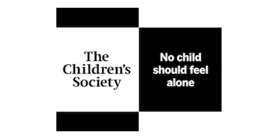


We give in a global way to the charity, Plan International UK, through which we sponsor two children – Francisca who lives in Brazil and Zeddy who lives in Kenya. We hold monthly non-uniform days where pupils can choose to wear their own clothes by donating to PLAN International.
PLAN International UK is a global children’s charity which supports girls and boys growing up in some of the world’s poorest communities, making sure they have access to the education, health care, clean water and future opportunities they need to thrive.

We also give to New Ways, supporting the poorest children in a primary school in Turkana, Northern Kenya in Africa.

New Ways Focus:

Water. Health. Education. Key areas of concern in Africa. And three areas in which New Ways is deeply involved.
Nutrition, Agriculture, Fishing. Three areas where improvement has had a significant impact. New Ways is active in all of these.

Our school is twinning with St Joseph’s Primary School in Nariokotome, Turkana County, Northern Kenya. In doing so your donations will cover the education and meals provided to the children who attend.

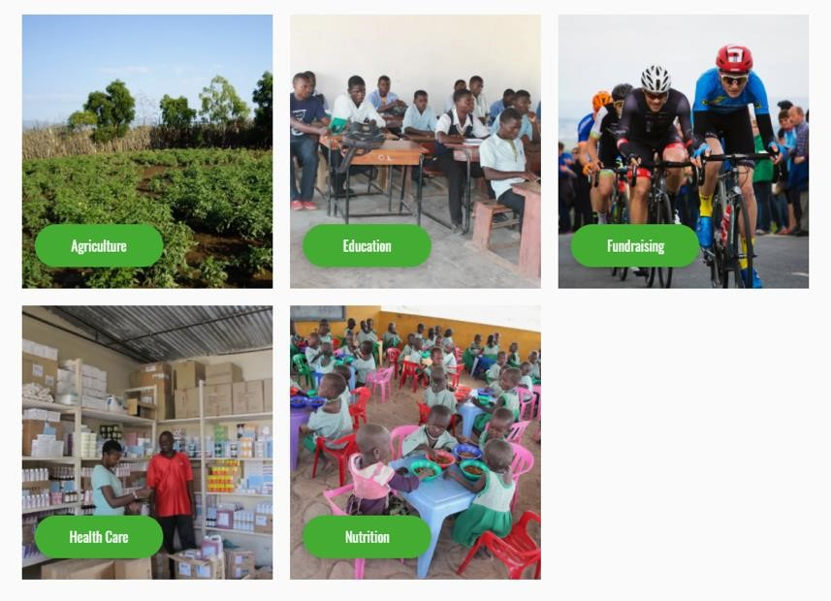



We raise money for the charity Christian Aid – providing support in a humanitarian crisis to people of all faiths and none.

We stand together in solidarity with our most marginalised global neighbours, of all faiths and none.
We chose this charity because in a humanitarian crisis, Christian Aid supports local aid workers to provide emergency support as soon as it is safe to do so.

Christian Aid began in 1945, when they were founded by British and Irish churches to help refugees following the Second World War. For more than 75 years, they have provided humanitarian relief and long-term development support for communities worldwide: suffering war, famine, drought and natural disasters. Christian Aid created the Disasters Emergency Committee (DEC) so that many development agencies could work together in times of humanitarian crisis.




Every November we subscribe to the national POPPY APPEAL.
.

We also support
Red Nose Day.

